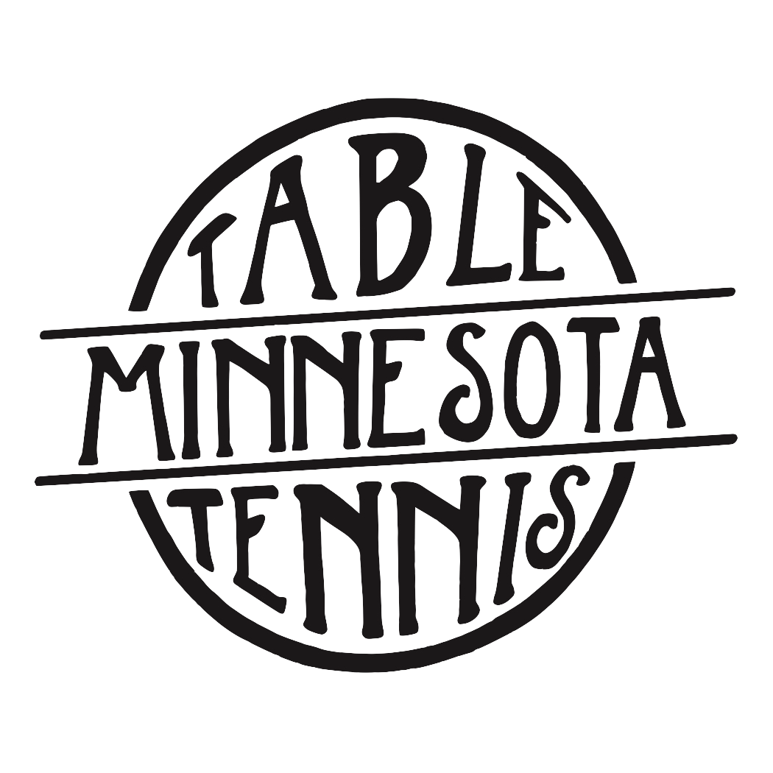After school junior drop in training

Where: Table Tennis Minnesota; 1185 Concord St. N, South St. Paul

Levels: All Levels

Length: Ongoing

Time: Tuesdays 3:30pm-5:30pm

Dates: Begins February 13th

Focus: Proper technique, foundation, footwork, strategy, game play, and
having fun!

Coaches: Joe Podvin: 2017 Minnesota State Singles and Doubles State
Champion. USATT Club Coach and SafeSport Certified. Additional coaches added to training as needed.

Ages/Level: Ages 7-18

Fee: Daily member rate: $5; daily non-member rate: $10

Contact: Joe Podvin, 651-353-2818, joepodvintt@gmail.com

