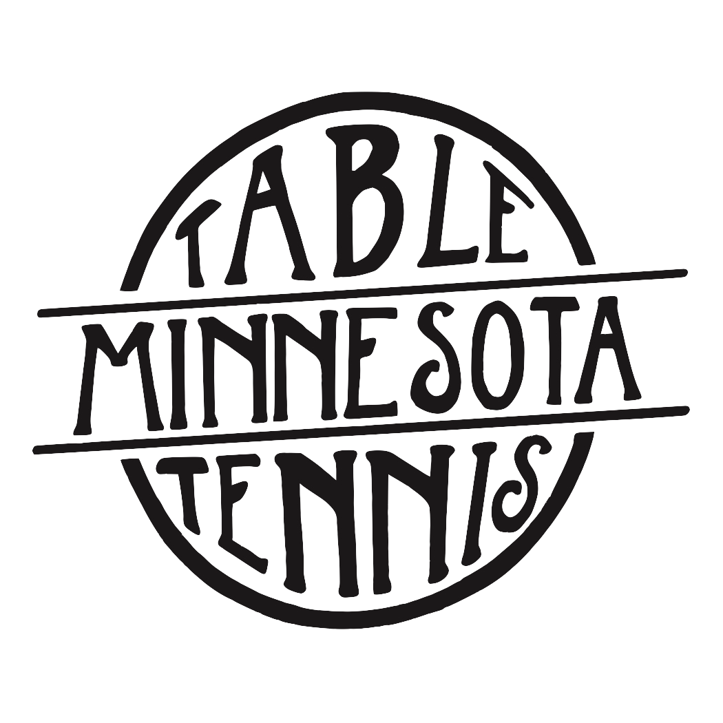Summer Junior Table Tennis Camps 2018

Where: Table Tennis Minnesota; 1185 Concord St. N, South St. Paul

Levels: All Levels

Length: 3 camps; each camp 1 week long; sign up for 1, 2, or all 3

Time: 9:00am to 3:30pm

Dates: June 18th-June 22nd; July 16th-July 20th; August 13th-August 17th

Focus: Proper technique, foundation, footwork, strategy, game play, and
having fun!

Coaches: Joe Podvin: 2017 Minnesota State Singles and Doubles State
Champion. USATT Club Coach and SafeSport Certified. Additional coaches added to training as needed.

Ages/Level: Ages 7-18

Lunch: Please bring box lunch daily

Fee: 1 or 2 per week camp member rate: $240; non-member rate: $270
**$50.00 discount for signing up for all 3 camps**

Shirt Fee: Shirt purchase only to be made for first time students: $25.00

Registration: Register at Podvintabletennis.com

Payment: Pay online by card
Cash or checks made out to Podvin Table Tennis, send to: 3421 Hennepin Ave apt 2, Minneapolis MN 55408 or give directly to Joe

Contact: Joe Podvin, 651-353-2818, joepodvintt@gmail.com
Registration deadlines June 17th, July 15th, and August 12th

