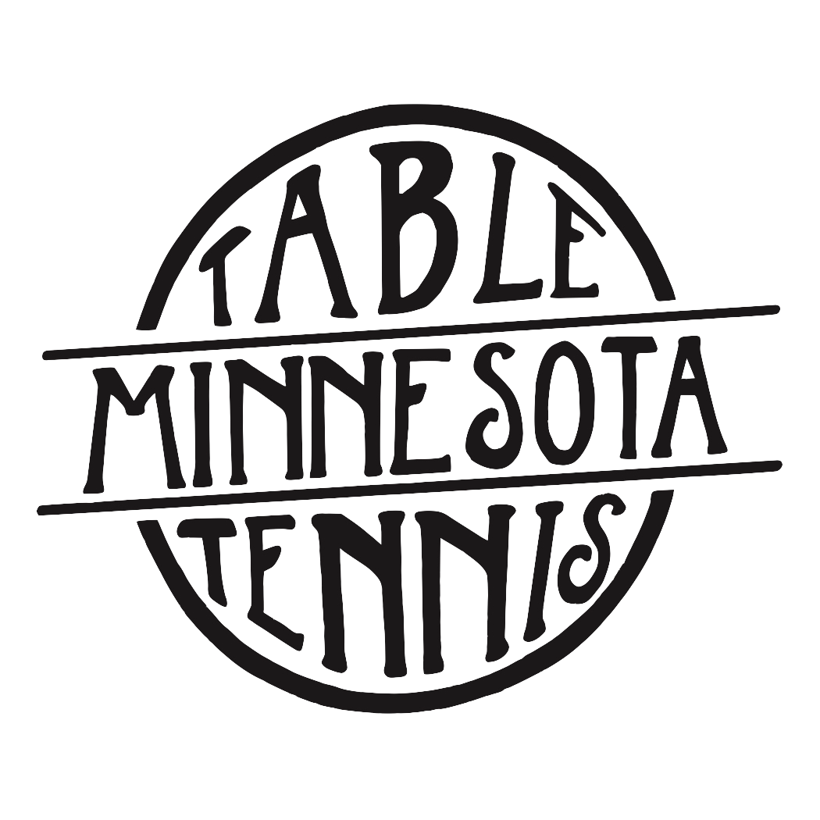Winter/Spring 2018 Junior Table Tennis Clinics

Where: Table Tennis Minnesota; 1185 Concord St. N, South St. Paul

Levels/Times: Loopers 1200 (advanced) and up: Sunday 11:00am-1:00pm
Blockers 800-1200 (intermediate): Sunday 1:00pm-3:00pm
Pushers 800 and below (beginner): Sunday 3:00pm-5:00pm

Length: 6 weeks; 2 hours per clinic session

Dates: First Session: February 18th, 25th and March 4th, 11th, 18th, 25th
Second Session: April 8th, 15th, 22nd, 29th and May 6th and 20th

Focus: Proper technique, foundation, footwork, strategy, game play, and
having fun!

Coaches: Joe Podvin: 2017 Minnesota State Singles and Doubles State
Champion. USATT Club Coach and SafeSport Certified. Additional coaches added to training as needed.

Ages/Level: Ages 7-18

Fee: Table Tennis MN member rate: $135; non-member rate: $150
**For membership information please call Table Tennis MN at
612-382-2892**

Shirt Fee: Shirt purchase only to be made for first time students: $25.00

Registration: Register at Podvintabletennis.com

Payment: Pay online by card
Cash or checks made out to Podvin Table Tennis, send to: 3421 Hennepin Ave apt 2, Minneapolis MN 55408 or give directly to Joe

Contact: Joe Podvin, 651-353-2818, joepodvintt@gmail.com
Registration deadline 2/8/2018

