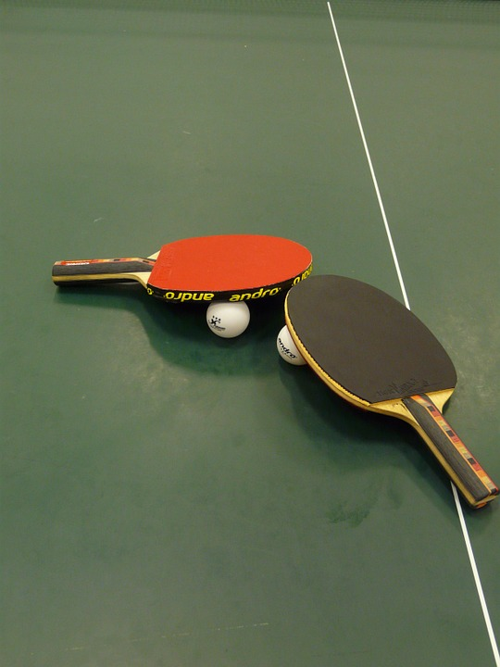
Table Tennis Minnesota BANQUET

Fellow Table tennis players

Please join us for a Banquet to celebrate our sport, bringing together players for a social event.

Whether you are a current or former player, here’s a chance to connect with other players.

Event details:

When: Sunday, May 20, 2018 from 5:00 PM till 8:00 PM.

Where: TST Creative Catering 1494 Dale Street North, St Paul MN 55117.

Who: All current and past players and their families are invited.

Cost: $15 per person will include a delicious meal and beverage (vegetarian option available). Type of payment accepted: Cash, check made out to MTTF, or credit card.

*Banquet proceeds will go towards Table Tennis Minnesota junior development*

Please RSVP/pay by May 18, to

Joe Podvin:651-353-2818 joepodvintt@gmail.com

Sandhya Joshi: 952-201-6339 sandhyajoshi@aol.com

Mitchell Seidenfeld: 612-382-2892 mitch@tabletennismn.com

